Baby khanoom e golam saaaaaaaambooli aleikom.
Sorry ke kamel nashod ishalla eid miam kamelesh mikonam o ye project e jaded e kheiliiiiii kheeeeeeeili kharaki minevisam baratoon. Eshgham ba arze maazerat bayad beshinin vase in document tozihat benevisi ye bar check koni grammer esh o code asho ye bar bekhooni eshkalash o doros koni baadam bazam sorry vaght o mokham nemikeshe layer e net moonde intoo naneveshtamesh.
Baaaaaaaaad digeeeee . . .
Aha code a ram vasat ferestadam.
Baby in document aram moratab kon ghashang reference page bezar vasash baad sar titr a ro bold kon lotfan size o rangeshoonam age avaz kardi kheili behtar mishe. Moratab kon in document e naghes e darb e daghoooon o AAAAAAAAAAAAAAAAAAAAAAGGGGGGGGGGGGEEEEEEEEEEE MAN EID NAIMADAM ALBAAAAATE
Ishaaaaaaaaaaaaaaallllllllllllllla ke sale khoooooooooooooobi dashte bashhhhhhhhhhi age nadidamet. Ye aaaaaaaaaaaaaaaaaaaaaaalaaaaaaaaaaaaaaaaaaaaaaaame mibooooooooosamet baby e khkoshgel o nazanin o ye donia mehrabooooooooooooooooooooooon am :-*

System use case

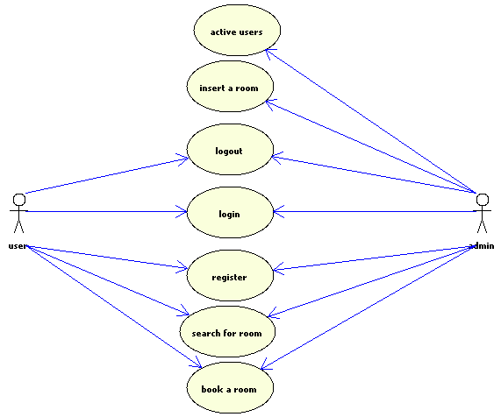

System prototype

Register.jsp
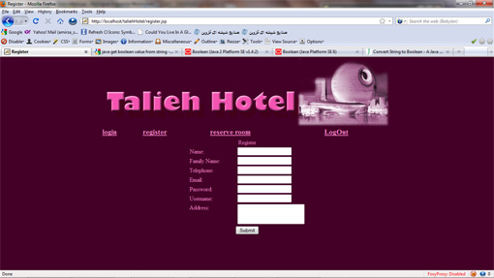
New users can register in the system, by completing and submitting the exist form in this page.
Login.jsp
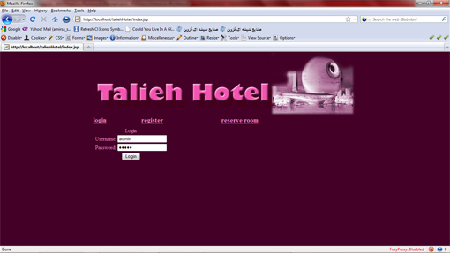
Users logged in the system through this page. If username equals admin, system redirect the logged in user into the administrative control panel.
Admin.jsp
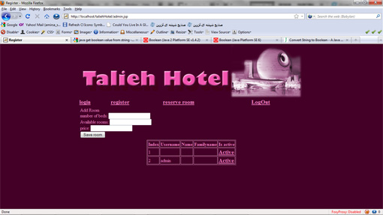
Administrator of the system in this page can view a list of all users which able the admin to activate or deactivate them. Activated users can book a room; the others only can search rooms.
Another capability of this page allows admin to inform people about availability of all rooms in their hotel. For instance, admin can easily add that his hotel has four number of single bed rooms and its daily price.

Reserve.jsp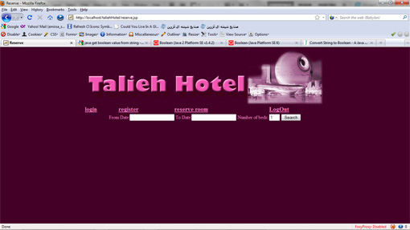
All people can view this page; they can also search between two days based on the number of the room bed.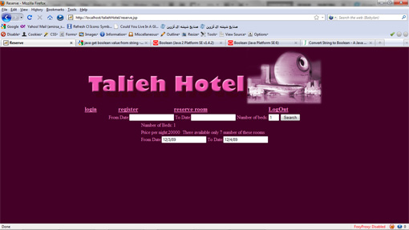
Only logged in users which are activated by the admin can view the book button after the search for a room. They can book the search result either.
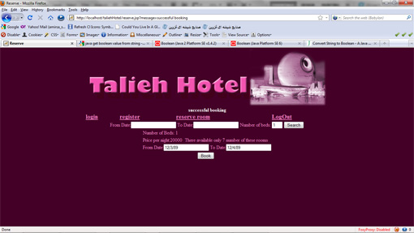

Technical info.
The system designed and implemented based on n-tired layer architecture. There are various layers which is considering as mentioned below.
- Data layer
In this layer database of the system placed. MYSQL manage this layer. The database contains many tables as shown below.
- Users:
This table contains all information about users
  - Varchar name
  - Varchar familyName
  - Text address
  - Varchar email
  - Varchar password
  - Varchar phone
  - Varchar username
  - Binary confirmed
- Room:
This table contains all information about available rooms in hotel
  - Integer id
  - Integer beds
  - Integer available
  - Integer price
- Booking:
This table contains all information about booked between specific dates
  - Varchar username
  - Integer roomId
  - Varchar fromDate
  - Varchar toDate

- Business layer
Definiiiiiiiiiiiiiiiiiiiiiiiiiiiiiiiition of business layeeeeeeeeeeeeeeer

/*
* To change this template, choose Tools | Templates
* and open the template in the editor.
*/

package Business;

import Common.*;

import java.sql.*;
import java.util.ArrayList;
/**
*
* @author Talieh Dastmalchi
*/
public class bsManager {

public ArrayList<UserENT> allUsers() {//this method creates an array list of all registered users in the system
ArrayList<UserENT> al = new ArrayList<UserENT>();
try{
Class.forName("com.mysql.jdbc.Driver");//creating the driver to connect to mysql
Connection con=DriverManager.getConnection("jdbc:mysql://localhost:3306/taliehhotel", "root", "root");//database connection necessitate information defines here
String sql="Select * from user";//an SQL query
Statement stmt=con.createStatement();//create an statement ResultSet rs = stmt.executeQuery(sql);//executing the query and getting a result

while(rs.next())
{//by the result value this loop create users
UserENT user = new UserENT();
user.setActive(rs.getBoolean("confirmed"));
user.setUserName(rs.getString("username"));
user.setName(rs.getString("name"));
user.setFName(rs.getString("familyName"));
al.add(user);//putting the database records in array blocks
}

rs.close();//closing the resultset
stmt.close();//closing the statement
con.close();//closing the connection
}
catch (Exception EX){
EX.printStackTrace();
}
return al;//return the list as the result of the method
}

public UserENT login(String u, String p) {//check the availability of a user based on compatibility of username and password, then return all its information in an entity
UserENT user = new UserENT();
try{
Class.forName("com.mysql.jdbc.Driver");
Connection con=DriverManager.getConnection("jdbc:mysql://localhost:3306/taliehhotel", "root", "root");
String sql="Select * from user where username = ? AND password = ? ";
PreparedStatement ps=con.prepareStatement(sql);
ps.setString(1,u);
ps.setString(2,p);
ResultSet rs = ps.executeQuery();

if(rs.next()){
user.setActive(rs.getBoolean("confirmed"));
user.setUserName(rs.getString("username"));
user.setName(rs.getString("name"));
user.setFName(rs.getString("familyName"));
}else{
user=null;
}

rs.close();
ps.close();
con.close();
}
catch (Exception EX){
user=null;
EX.printStackTrace();
}

return user;
}

public void insertBook(ReserveENT ent) {//save a booking information
try{
Class.forName("com.mysql.jdbc.Driver");
Connection con=DriverManager.getConnection("jdbc:mysql://localhost:3306/taliehhotel", "root", "root");
String sql="Insert into booking (userName, fromDate, toDate, roomid) values (?,?,?,?)";
PreparedStatement ps = con.prepareStatement(sql);
ps.setString(1,ent.getUserName());
ps.setString(2,ent.getSDate());
ps.setString(3,ent.getEDate());
ps.setInt(4,ent.getRoomId());

ps.execute();

ps.close();
con.close();

}
catch (Exception EX){
EX.printStackTrace();

}
}

public void insertRoom(RoomENT rent) {//save a room information
try{
Class.forName("com.mysql.jdbc.Driver");
Connection con=DriverManager.getConnection("jdbc:mysql://localhost:3306/taliehhotel", "root", "root");
String sql="Insert into room(beds, available, price) values (?,?,?)";
PreparedStatement ps = con.prepareStatement(sql);
ps.setInt(1,rent.getBeds());
ps.setInt(2,rent.getNumRooms());
ps.setInt(3,rent.getPrice());
ps.execute();

ps.close();
con.close();

}
catch (Exception EX){
EX.printStackTrace();
}
}

public boolean register(UserENT UserENT) {//register a user and save its information
try{
Class.forName("com.mysql.jdbc.Driver");
Connection con=DriverManager.getConnection("jdbc:mysql://localhost:3306/taliehhotel", "root", "root");
String sql="Insert into user (name, familyName, address, email, password, phone, username, confirmed) values (?,?,?,?,?,?,?,?)";
PreparedStatement ps = con.prepareStatement(sql);
ps.setString(1,UserENT.getName());
ps.setString(2,UserENT.getFName());
ps.setString(3,UserENT.getAddress());
ps.setString(4,UserENT.getEmail());
ps.setString(5,UserENT.getPassword());
ps.setString(6,UserENT.getPhoneNo());
ps.setString(7,UserENT.getUserName());
ps.setBoolean(8,UserENT.isActive());
ps.execute();

ps.close();
con.close();
return true;
}
catch (Exception EX){
EX.printStackTrace();
return false;
}
}

public RoomENT searchForRoom(ReserveENT reserveENT) {//search for a room between two specific dates
RoomENT roomENT = new RoomENT();
try{
Class.forName("com.mysql.jdbc.Driver");
Connection con=DriverManager.getConnection("jdbc:mysql://localhost:3306/taliehhotel", "root", "root");
String sql="Select * from room where beds like ?";
PreparedStatement ps=con.prepareStatement(sql);
ps.setInt(1, reserveENT.getNumOfBeds());
ResultSet rs = ps.executeQuery();
while(rs.next())
{
roomENT.setId(rs.getInt("id"));
roomENT.setNumRooms(rs.getInt("available"));
roomENT.setBeds(rs.getInt("beds"));
roomENT.setPrice(rs.getInt("price"));
}
rs.close();
ps.close();
sql="Select * from booking where roomId = ? and toDate > ? and fromDate < ? ";
ps=con.prepareStatement(sql);

ps.setInt(1, roomENT.getId());
ps.setString(2, reserveENT.getSDate());
ps.setString(3, reserveENT.getEDate());
rs = ps.executeQuery();
int counter = 0;
while(rs.next())
{
counter++;
}
roomENT.setNumRooms(roomENT.getNumRooms()-counter);
rs.close();
ps.close();
con.close();
}
catch (Exception EX){
EX.printStackTrace();
}
return roomENT;
}

public void activation(boolean x, String uname) {//this method activate or deactivate users by update the confirmation status of them
try{
Class.forName("com.mysql.jdbc.Driver");
Connection con=DriverManager.getConnection("jdbc:mysql://localhost:3306/taliehhotel", "root", "root");
String sql="UPDATE user SET confirmed = ? WHERE username = ? ";
PreparedStatement ps=con.prepareStatement(sql);
ps.setBoolean(1,x);
ps.setString(2,uname);
ps.execute();

ps.close();

con.close();
}
catch (Exception EX){
EX.printStackTrace();
}
}

}

- Web layer
This layer contains Servlets and JSPs.
- Login servlet
try {
bsManager manager = new bsManager();
//start the getting parameters from the request in JSP
String u = request.getParameter("userN");
String p = request.getParameter("pass");
//end of the getting parameters from the request in JSP

UserENT ent = new UserENT();
ent=manager.login(u,p);//calling the method from the business layer and getting the logged in user info
if(ent!=null){
request.getSession().setAttribute("userSession", ent);
//put the logged in user info in the userSessoin session
if(ent.getUserName().equalsIgnoreCase("admin")){//if user was admin redirect it to the userList servlet
response.sendRedirect("userList");
}else{//redirect the correct user to home with a welcome note
response.sendRedirect("index.jsp?message=welcome Mr-MRS " + ent.getName()+" " + ent.getFName());
}
}else{//if username or password was invalid users will see this message
response.sendRedirect("index.jsp?message=Invalid username or password");
}
- Logout servlet
//logout. Invalidate all sessions and redirect the user to home
request.getSession(true).invalidate();
response.sendRedirect("index.jsp");
- Book servlet
ReserveENT rent = new ReserveENT();
rent.setSDate(request.getParameter("sdate"));
rent.setEDate(request.getParameter("edate"));
rent.setUserName(request.getParameter("userName"));
rent.setRoomId(Integer.parseInt(request.getParameter("roomId")));
bsManager bs = new bsManager();
bs.insertBook(rent);
response.sendRedirect("reserve.jsp?message=successful booking");
- Book servlet
ReserveENT rent = new ReserveENT();
rent.setSDate(request.getParameter("sdate"));
rent.setEDate(request.getParameter("edate"));
rent.setUserName(request.getParameter("userName"));
rent.setRoomId(Integer.parseInt(request.getParameter("roomId")));
bsManager bs = new bsManager();
bs.insertBook(rent);
response.sendRedirect("reserve.jsp?message=successful booking");
- Confirmuser servlet
boolean p = Boolean.parseBoolean(request.getParameter("activate"));
String uname = request.getParameter("activateId");
bsManager bs = new bsManager();
bs.activation(p,uname);
response.sendRedirect("userList");
- Insertroom servlet
bsManager bs = new bsManager();
RoomENT rent = new RoomENT();
rent.setBeds(Integer.parseInt(request.getParameter("numberOfBeds")));
rent.setNumRooms(Integer.parseInt(request.getParameter("availability")));
rent.setPrice(Integer.parseInt(request.getParameter("price")));
bs.insertRoom(rent);

response.sendRedirect("reserve.jsp");
- register servlet
bsManager manager = new bsManager();
UserENT ent = new UserENT();
ent.setName(request.getParameter("name"));
ent.setFName(request.getParameter("fname"));
ent.setAddress(request.getParameter("address"));
ent.setEmail(request.getParameter("email"));
ent.setPassword(request.getParameter("password"));
ent.setPhoneNo(request.getParameter("phone"));
ent.setUserName(request.getParameter("usern"));
boolean registered = manager.register(ent);
if(registered){
response.sendRedirect("register.jsp?message=Thanks for your registration");
}else{
response.sendRedirect("register.jsp?message=Registration faild");
}
- searchforroom servlet
ReserveENT rent = new ReserveENT();
bsManager bs = new bsManager();
RoomENT ent = new RoomENT();
if(request.getParameter("numberOfBeds")!=null){
rent.setSDate(request.getParameter("startDate"));
rent.setEDate(request.getParameter("endDate"));
rent.setNumOfBeds(Integer.parseInt(request.getParameter("numberOfBeds")));
ent = bs.searchForRoom(rent);
if(ent.getNumRooms()<=0){
request.getSession().setAttribute("reserveSession", null);
request.getSession().setAttribute("roomSession", null);
response.sendRedirect("reserve.jsp?message=Sorry right now there is no available of the searched room");
}else{
request.getSession().setAttribute("reserveSession", rent);
request.getSession().setAttribute("roomSession", ent);
response.sendRedirect("reserve.jsp");
}

}else{
request.getSession().setAttribute("reserveSession", null);
request.getSession().setAttribute("roomSession", null);
response.sendRedirect("reserve.jsp");
}
- userList servlet
bsManager bs = new bsManager();
ArrayList<UserENT> al = bs.allUsers();
request.getSession().setAttribute("userListSession", al);
response.sendRedirect("admin.jsp");
- Common layer
Diffffffffffffiniiiiiiiitiiiionn of common layer
- USERENT
/*
* To change this template, choose Tools | Templates
* and open the template in the editor.
*/

package Common;

/**
*
* @author Talieh Dastmalchi
*/
public class UserENT {
private String name;
private String fName;
private String phoneNo;
private String email;
private boolean active=false;
private String address;
private String password;
private String userName;

public String getName() {//getter method for the name attribute
return name;
}

public void setName(String name) {//setter method for the name attribute
this.name = name;
}

public String getFName() {
return fName;
}

public void setFName(String fName) {
this.fName = fName;
}

public String getPhoneNo() {
return phoneNo;
}

public void setPhoneNo(String phoneNo) {
this.phoneNo = phoneNo;
}

public String getEmail() {
return email;
}

public void setEmail(String email) {
this.email = email;
}

public boolean isActive() {
return active;
}

public void setActive(boolean active) {
this.active = active;
}

public String getAddress() {
return address;
}

public void setAddress(String address) {
this.address = address;
}

public String getPassword() {
return password;
}

public void setPassword(String password) {
this.password = password;
}

public String getUserName() {
return userName;
}

public void setUserName(String userName) {
this.userName = userName;
}

}

- ROOMENT
/*
* To change this template, choose Tools | Templates
* and open the template in the editor.
*/

package Common;

/**
*
* @author Talieh Dastmalchi
*/
public class RoomENT {
private int beds;
private int numRooms;
private int id;
private int price;

public int getBeds() {
return beds;
}

public void setBeds(int beds) {
this.beds = beds;
}

public int getNumRooms() {
return numRooms;
}

public void setNumRooms(int numberOfRooms) {
this.numRooms = numberOfRooms;
}

public int getId() {
return id;
}

public void setId(int id) {
this.id = id;
}

public int getPrice() {
return price;
}

public void setPrice(int price) {
this.price = price;
}

}
- RESERVEENT
/*
* To change this template, choose Tools | Templates
* and open the template in the editor.
*/

package Common;

import java.sql.Date;

/**
*
* @author Talieh Dastmalchi
*/
public class ReserveENT {
private String sDate;
private String eDate;
private int numOfBeds;
private int roomId;
private String userName;

public String getSDate() {
return sDate;
}

public void setSDate(String sDate) {
this.sDate = sDate;
}

public String getEDate() {
return eDate;
}

public void setEDate(String eDate) {
this.eDate = eDate;
}

public int getNumOfBeds() {
return numOfBeds;
}

public void setNumOfBeds(int numOfBeds) {
this.numOfBeds = numOfBeds;
}

public int getRoomId() {
return roomId;
}

public void setRoomId(int roomId) {
this.roomId = roomId;
}

public String getUserName() {
return userName;
}

public void setUserName(String userName) {
this.userName = userName;
}

}
- RMI layer
Difffffffffffffffinition RMI
- RMIServer
//all methods which designer wants to be callable to connect remotely to other server defines here
/*
* To change this template, choose Tools | Templates
* and open the template in the editor.
*/

package RMI;

import java.net.MalformedURLException;
import java.rmi.Naming;
import java.rmi.RemoteException;
import java.rmi.server.UnicastRemoteObject;
import java.util.ArrayList;

import Business.bsManager;
import Common.ReserveENT;
import Common.RoomENT;
import Common.UserENT;

/**
*
* @author Talieh Dastmalchi
*/
public class SaleRMIServer extends UnicastRemoteObject implements SaleRMIInterface {
public static void main(String[] args){
try{
SaleRMIServer obj = new SaleRMIServer();
}catch (RemoteException ex) {
ex.printStackTrace();
}

}

public SaleRMIServer() throws RemoteException{
try{
Naming.rebind("SaleRMIServer", this);
}catch (MalformedURLException ex){
//Logger.getLogger(SaleRMIServer.class.getName()).log(Level.SEVERE, null, ex);
//server - mine
ex.printStackTrace();
//client -
throw new RemoteException(ex.getMessage());
}

}
public String helloRMI(String name) throws RemoteException {
//throw new UnsupportedOperationException("Not support yet.");
return name+" Welcome to RMI";
}

public void activation(boolean p, String uname) throws RemoteException {
bsManager bsManager = new bsManager();
bsManager.activation(p, uname);
}

public ArrayList<UserENT> allUsers() throws RemoteException {
bsManager bsManager = new bsManager();

return bsManager.allUsers();
}

public void insertBook(ReserveENT ent) throws RemoteException {
bsManager bsManager = new bsManager();
bsManager.insertBook(ent);

}

public void insertRoom(RoomENT rent) throws RemoteException {
bsManager bsManager = new bsManager();
bsManager.insertRoom(rent);

}

public UserENT login(String u, String p) throws RemoteException {
bsManager bsManager = new bsManager();

return bsManager.login(u, p);
}

public boolean register(UserENT UserENT) throws RemoteException {
bsManager bsManager = new bsManager();

return bsManager.register(UserENT);
}

public RoomENT searchForRoom(ReserveENT reserveENT) throws RemoteException {
bsManager bsManager = new bsManager();
return bsManager.searchForRoom(reserveENT);
}

}

- RMIInterface
All exist methods in the RMI server defines here and should call from this interface
/*
* To change this template, choose Tools | Templates
* and open the template in the editor.
*/

package RMI;

import java.rmi.Remote;
import java.rmi.RemoteException;
import java.util.ArrayList;

import Common.ReserveENT;
import Common.RoomENT;
import Common.UserENT;

/**
*
* @author Talieh Dastmalchi
*/
public interface SaleRMIInterface extends Remote {
public String helloRMI (String name) throws RemoteException;
public ArrayList<UserENT> allUsers() throws RemoteException;
public UserENT login(String u, String p) throws RemoteException;
public void insertBook(ReserveENT ent) throws RemoteException;
public void insertRoom(RoomENT rent) throws RemoteException;
public boolean register(UserENT UserENT) throws RemoteException;
public RoomENT searchForRoom(ReserveENT reserveENT) throws RemoteException;
public void activation(boolean p, String uname) throws RemoteException;
}

